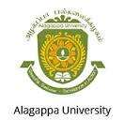 |  | ALAGAPPA UNIVERSITY  (A State University Reaccredited with “A” Grade by NAAC)  KARAIKUDI – 630 003 | 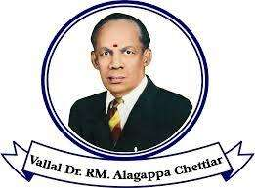
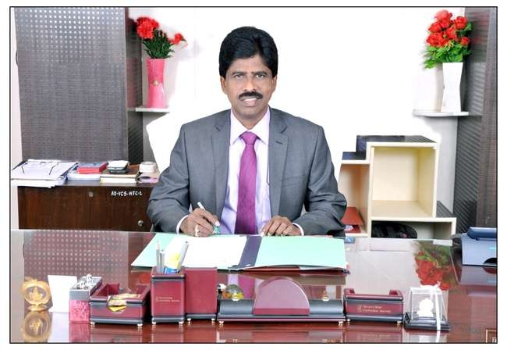
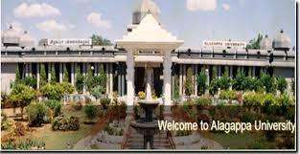
ALAGAPPA UNIVERSITY
(Reaccredited with “A” Grade by NAAC)
KARAIKUDI – 630 003

CONSUMER AWARENESS CLUB
Report (2016 - 2017)

DEPARTMENT OF CORPORATE SECRETARYSHIIP
SCHOOL OF MANAGEMENT
ALAGAPPA UNIVERSITY
KARAIKUDI- 630 004

CONSUMER AWARENESS CLUB
Aim and Purpose  (Suggested) | - To create awareness among students about the provisions and procedures relating to consumer fora.
 | - To conduct Essay and Elocution competitions to the students on Consumer Rights and Welfare
 | - To celebrate World Consumer Rights Day and organize Seminars on Consumer Rights and Protection / Right to Information

Name | Designation & Dept./Division/College. | Status
Faculty | Dr.SP.MATHIRAJ,  Associate Professor  Department of Corporate Secretaryship  Alagappa University,  Karaikudi-04. | Coordinator
Faculty | Dr.G.RAMALINGAM,  Assistant Professor  Department of Nanoscience and Tech  Alagappa University,  Karaikudi-04. | Member
Faculty | Dr.S.SANTHOSHKUMAR,  Assistant Professor  Department of Computer Science  Alagappa University,  Karaikudi. | Member
Faculty | Dr.A.CHANDRASEKAR, Asst. Registrar  Controller of Examination Section  Alagappa University,  Karaikudi-03. | Member
Student Representative | (From Coordinator’s Dept.)  RM.ALAGU NACHIYAR  II YEAR MBA(CS),  Alagappa University  Karaikudi-04. | Member
Student Representative | (From Coordinator’s Dept.)  S.BERNISHA  II YEAR M.Com  Alagappa University  Karaikudi-04. | Member
.

Activities  (Suggested) | Student studies on rural consumer behaviour, their awareness level of consumer rights, etc
 | Programs for public/retailers/businesses

Objectives of the club:
- To celebrate March 15th of every year as world consumer rights day.
- To create awareness about the consumer rights among students through various competitions.
- To invite experts to deliver special lecture on consumer rights.

Activities carried out for the March 15th, 2017:
- The consumer club in association organized the following competitions on March 15th in the Department of Corporate Secretaryship.
- Inter collegiate essay writing, slogan training and oratorical competitions.
- Certificate of merit and Prizes were distributed to the winners of the competitions.
- Certificate of participation were distributed to all the participants.
Prof. Marx – Chair Person, National Confederation of Human Rights, Chennai was invited to deliver a special lecture the students of School of Management.

REPORT FOR THE CONDUCT OF WORLD CONSUMER RIGHTS DAY ON 15-03-2017

The Department of Corporate Secretaryship and Consumer Club of Alagappa University jointly organized the World Consumer Rights Day celebrations on 15.03.2017. Inaugurating the programme and while delivering the presidential address Programme Dr.V.Manickavasagam, Dean, Faculty of Management, Alagappa University said that World Consumer Rights Day is an annual opportunity to celebrate and display solidarity between the consumer activities globally. Most important is that it is time to promote the consumer’s basic rights, to demand the conservation and respect for these rights and to oppose exploitation by the market and the social injustice that is poorly valued. This year the theme of World Consumer Rights Day is “Building a Digital world the Consumers can trust” and the purpose is to raise campaign around the world for building a safe digital world. He appealed to the students to be aware of their rights and alert while consuming the goods and services.
Dr.J.Jeyakanthan, Member Syndicate, Alagappa University offered felicitations, he expressed his happiness in sharing the information about the use of sensors for detecting the quality of bottle drinks. He instructed the students to implements the rights of consumer. Prof. Marx, Chair Person, National Confederation of Human Rights, Chennai delivered the keynote address and appealed to the corporate for providing safety to the consumers and to maintain the ethics and underlined the awareness of safety from drugs and steroids. The prizes were distributed by the Chief Guest Prof.Marx to the winners of the competition conducted on the eve of World Consumer Rights Day. Earlier Dr.SP.Mathiraj, Co-ordinator Consumer Club welcomed the gathering and Dr.S.Santhosh Kumar, Member Consumer Club proposed Vote of thanks.

Glimpses of World Consumer Rights Day

